Installing the C++ Toolchain
Use the following commands in the terminal to install the C++ toolchain:
sudo apt-add-repository ppa:byteit101/frc-toolchain
Enter your sudo password and press enter when prompted.
sudo apt update
This step might take a few minutes.
sudo apt install frc-toolchain
Installing Eclipse Mars

Download the Eclipse Mars package from http://www.eclipse.org/downloads/packages/eclipse-ide-cc-developers/mars1 (choose Linux 64-bit on an x86_64 machine, or 32-bit for an x86 machine). Click “Save File” and continue.

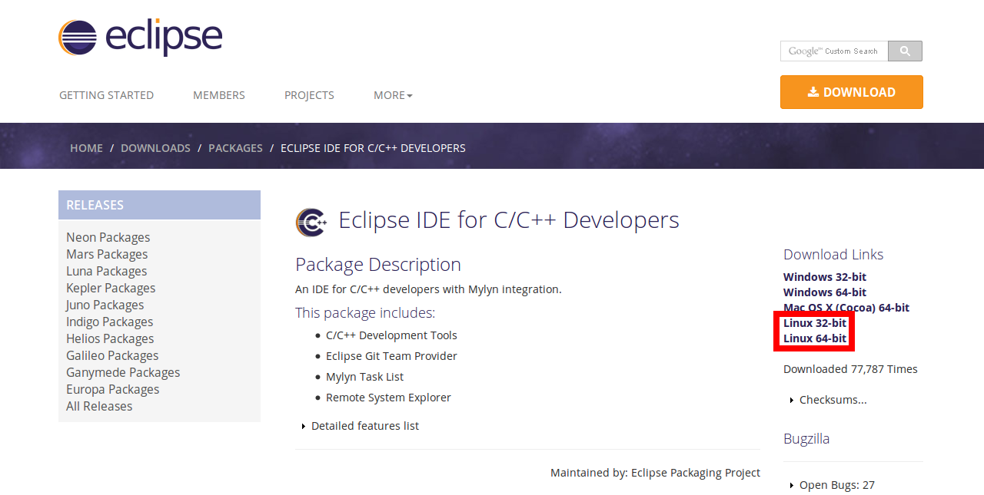
Then, in the terminal unpack the tar.gz using the following commands.
sudo su
Escalate user privileges. You will be prompted to input your sudo password.
cd /home/<youruser>/Downloads
Change your path to the filepath of the download (probable /home/yourusername/Downloads).
tar -xzf <filename.tar.gz>
Decompress the tar.gz file. This will make a directory called “eclipse” where all the unzipped files are stored.

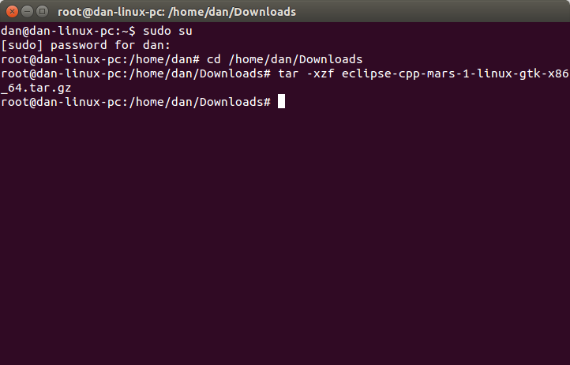
Now there should be a directory in Downloads called “eclipse” with a file called “eclipse” inside. This is the executable file. You can create a shortcut to your desktop using the following process:
Right click “eclipse” and click on “Make Link.” You can move this link to your desktop and rename it to whatever you want.

Before you can run Eclipse, make sure you have a JDK or JRE installed. To install a JDK, execute the following command:
sudo apt-get install openjdk-7-jdk

Setting up Eclipse:
First thing is you're going to get an error saying that g++ is not linked. First, in the Ubuntu Software Center, install “GNU C++ Compiler”. Then change the following setting:

Window->Preferences->C/C++->Build->Settings->Discovery->CDT GCC Built In Compiler Settings [Shared]
From: ${COMMAND} -E -P -v -dD “${INPUTS}”
To: /usr/bin/${COMMAND} -E -P -v -dD “${INPUTS}”

Next, follow the guide described: https://wpilib.screenstepslive.com/s/4485/m/13810/l/145002-installing-eclipse-c-java#ConfiguringEclipse (Starting at Configuring Eclipse).

Downloading the github repo:
Go to https://github.com/FRCTeam263/FRC_2015_2016 and click “Download ZIP” on the righthand side.

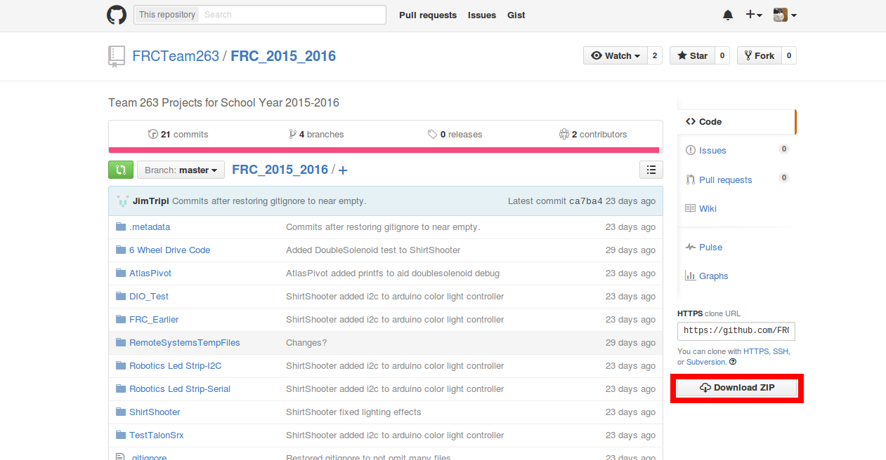
Unzip the file after the download is finished. Now import the project into Eclipse (File->Import->General->Existing Projects into Workspace).
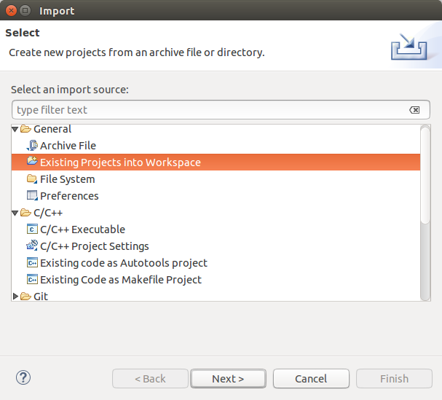

Now choose the unpacked file's directory as the root directory. Make sure “Search for nested projects” and “Copy projects into workspace” are checked off, click “Select All”, then press finish.
